**Topics: Descriptive Statistics and Probability**

1. Look at the data given below. Plot the data, find the outliers and find out $μ,σ,σ^{2}$

|  |  |
| --- | --- |
| **Name of company** | **Measure X** |
| Allied Signal | 24.23% |
| Bankers Trust | 25.53% |
| General Mills | 25.41% |
| ITT Industries | 24.14% |
| J.P.Morgan & Co. | 29.62% |
| Lehman Brothers | 28.25% |
| Marriott | 25.81% |
| MCI | 24.39% |
| Merrill Lynch | 40.26% |
| Microsoft | 32.95% |
| Morgan Stanley | 91.36% |
| Sun Microsystems | 25.99% |
| Travelers | 39.42% |
| US Airways | 26.71% |
| Warner-Lambert | 35.00% |

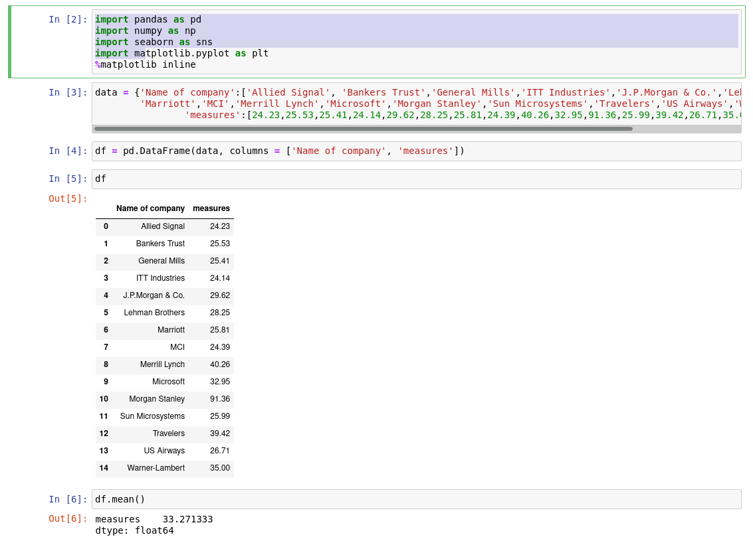

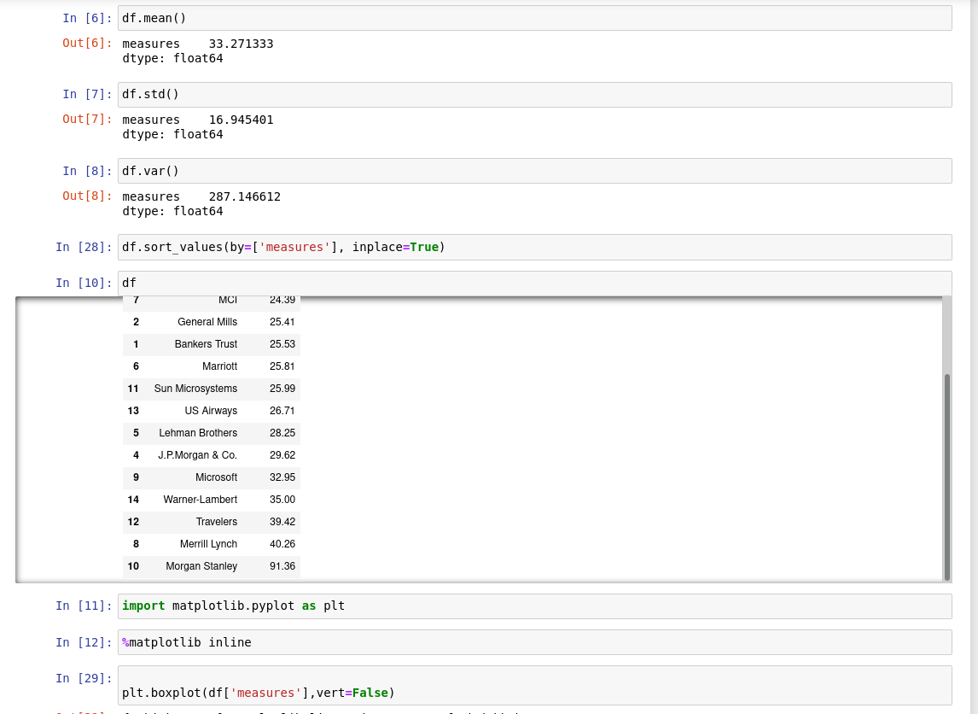

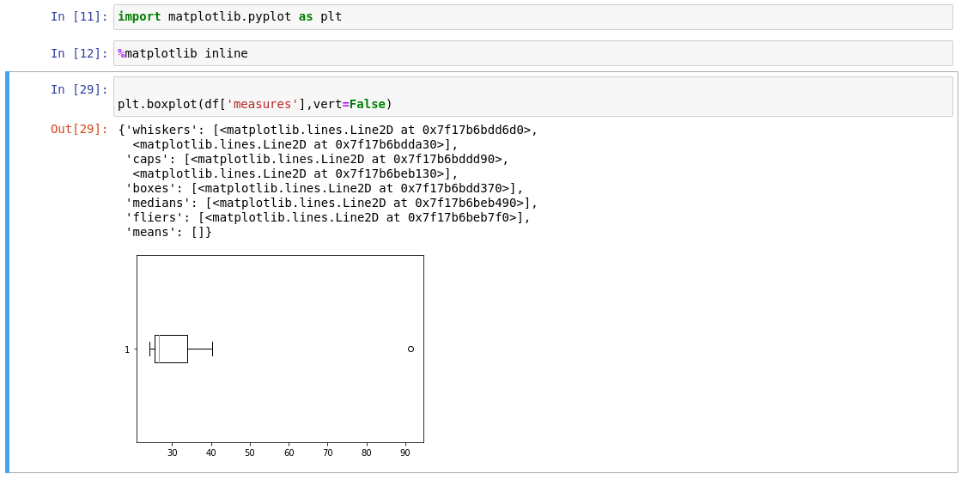**ANS: Mean = 33.2713**

**Variance = 287.1330**

**Standard Deviation = 16.945**

**From the Observations,**

**Morgan Stanley is an outlier of 91.36**



Answer the following three questions based on the box-plot above.

1. What is inter-quartile range of this dataset? (please approximate the numbers) In one line, explain what this value implies.

Ans:IQR= Q3 – Q1 = 12 – 5 = 7 , IQR represents middle 50% data.

1. What can we say about the skewness of this dataset?

Ans: Mean is less than median, so the box plot is Right skewed.

1. If it was found that the data point with the value 25 is actually 2.5, how would the new box-plot be affected?

Ans: The new Box plot will have no outliers in it.



Answer the following three questions based on the histogram above.

1. Where would the mode of this dataset lie?

ANS:5,6,7,8 with frequency of 20.

1. Comment on the skewness of the dataset.

Skewed to right

Ans: Right skewed, as long tail towards Right.

1. Suppose that the above histogram and the box-plot in question 2 are plotted for the same dataset. Explain how these graphs complement each other in providing information about any dataset.

Ans:Both shows outliers as 25 and it is skewed to right.

1. AT&T was running commercials in 1990 aimed at luring back customers who had switched to one of the other long-distance phone service providers. One such commercial shows a businessman trying to reach Phoenix and mistakenly getting Fiji, where a half-naked native on a beach responds incomprehensibly in Polynesian. When asked about this advertisement, AT&T admitted that the portrayed incident did not actually take place but added that this was an enactment of something that “could happen.” Suppose that one in 200 long-distance telephone calls is misdirected. What is the probability that at least one in five attempted telephone calls reaches the wrong number? (Assume independence of attempts.)

**ANS:0.025**

1. Returns on a certain business venture, to the nearest $1,000, are known to follow the following probability distribution

|  |  |
| --- | --- |
| x | P(x) |
| -2,000 | 0.1 |
| -1,000 | 0.1 |
| 0 | 0.2 |
| 1000 | 0.2 |
| 2000 | 0.3 |
| 3000 | 0.1 |

1. What is the most likely monetary outcome of the business venture?

Ans: 2000

1. Is the venture likely to be successful? Explain

Ans: Yes, there are 60% chances of getting a positive return and 20% chances of negative returns or debts

1. What is the long-term average earning of business ventures of this kind? Explain

Ans: Long term returns = ((-2000*1)+ (-1000*1)+ (1000*2)+ (2000*3)+ (3000*1) / 6) = 8000/6 = 1333

1. What is the good measure of the risk involved in a venture of this kind? Compute this measure

Ans: Good measure is, Positive returns (profits) probability tends to be more than negative returns (loss). i.e. 60% probability of profits and 20% probability of loss.